Electrical and Electronic workshop

Lab No 10

Introduction to PSpice Schematics

Objectives:

How to use PSpice and making circuits on it.

Apparatus:

- Download PSpice
- Install PSpice
- Draw sample circuit which u want to design on PSPice
Theory:

PSpice stands for Personal (Computer) Simulation Program with Integrated Circuit Emphasis. It is a tool to design and develop analog circuits and to simulate the behavior of a circuit. One can design a schematic diagram and develop a PCB of several layers. Using this tool you will know how your circuit is likely to behave in real world and when you prepare PCB assembly, it is likely to follow nearby result of circuit design on pspice simulator. Simulation result can be displayed on real
axis.
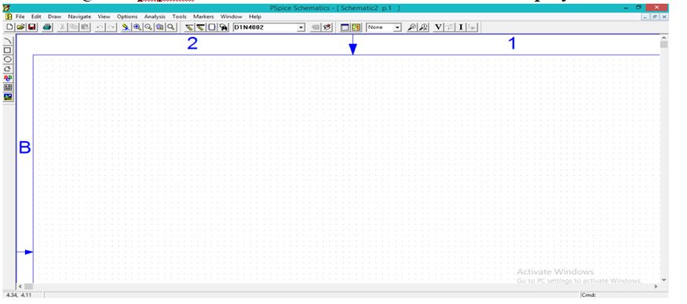

Figure no. 13.1 PSPice

We will design half wave rectifier as a sample circuit on PSPice

Procedure

- Open PSpice schematics
- Click on the icon get new part as given below

Electrical and Electronic workshop
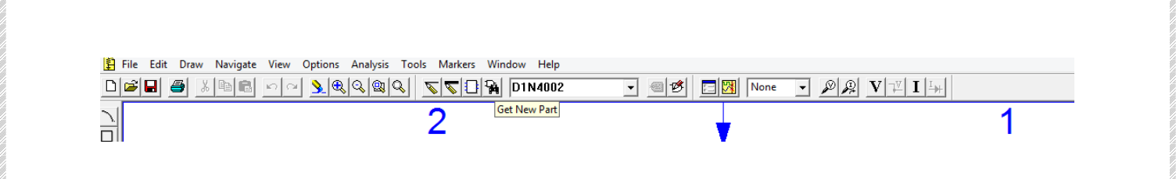

Figure no. 13.2

3. Choose the required component you want according to your circuit diagram.
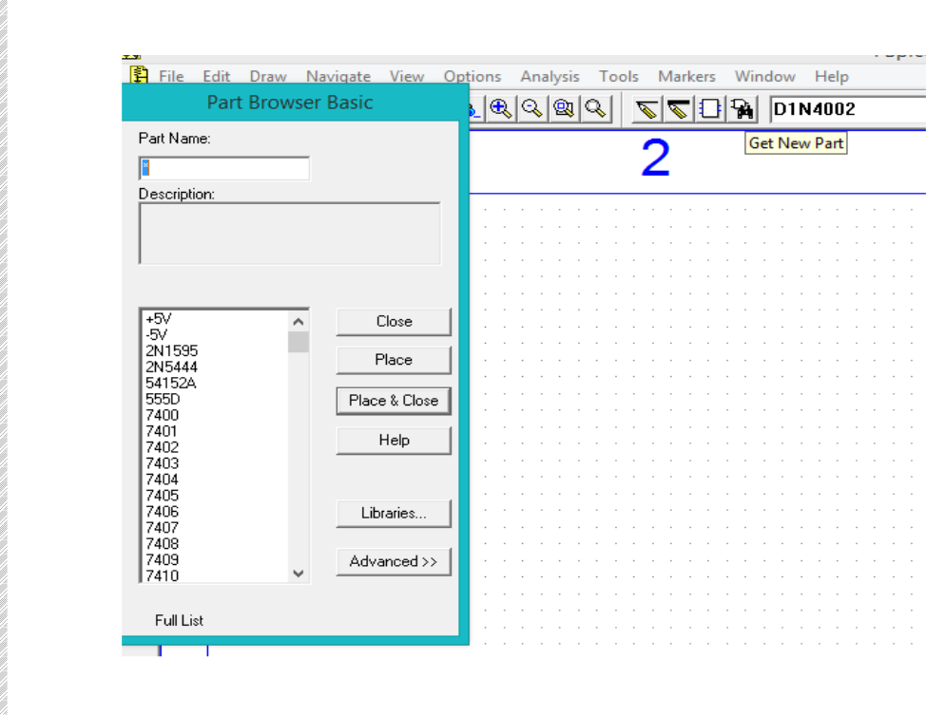

- Type the part name in “part browser basic box and write that component name.
- Every component must be created carefully by assigning its specifications.
- Connect components by “Draw wire” option.

Precautions:

- Assign input voltage carefully.
- Components specifications must be assign.

- Attribute value must be set carefully so the plot should be examined carefully

Lab Exercise:

Q no. 1 Simulate half wave rectifier on PSpice and attach its result in below space.

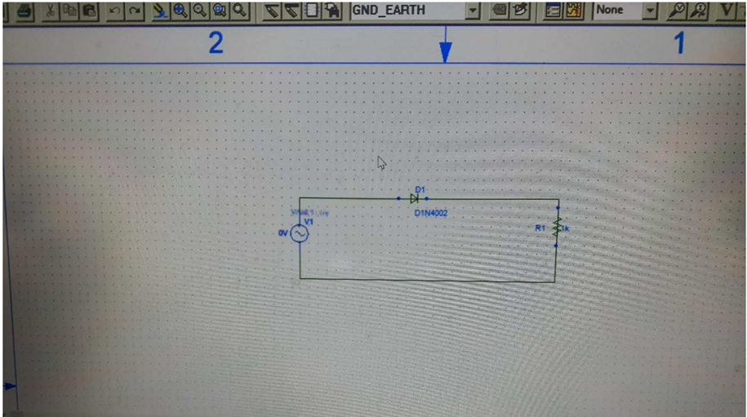

Output:

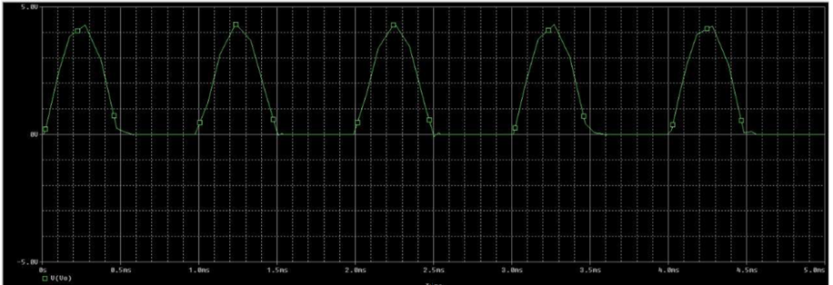

Q no. 2 Simulate full wave bridge rectifier circuit on pspice. Also attach its result.

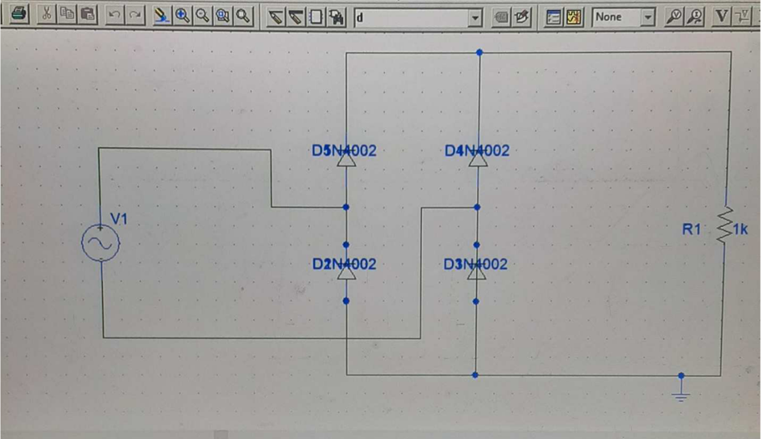

Output:

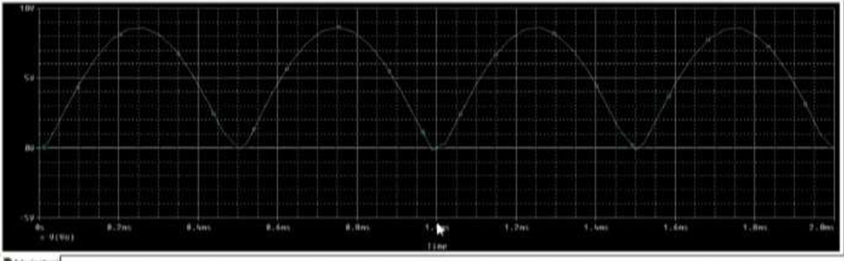

Conclusions: Describe your Comments & observations in the space given below.
I made half and full wave rectifier on pspice first I made half wave rectifier and then full wave rectifier. I assign them voltage and frequency value according to my will then
I plot a graph , graph give all the information first it tired me a lot but when I made circuit I was very happy to made a circuit on laptop and in such a accurate way.

